Intelligent Hospital Asset Tracking and Equipment Management Platform

ASSESSMENT TOOL 2
Submitted in the partial fulfilment for the Course of
CSA1012-SOFTWARE ENGINEERING
to the award of the degree of
BACHELOR OF ENGINEERING
IN
COMPUTER SCIENCE ENGINEERING
Submitted by
Ashwin S (192311410)
Under the Supervision of
ANITADAVAMANI K

SIMATS ENGINEERING
Saveetha Institute of Medical and Technical Sciences
Chennai-602105

Annexure A – Scenario-Based Requirement Analysis
Assigned Problem Statement: Intelligent Hospital Asset Tracking and Equipment Management Platform — an RFID/BLE/IoT-based system for real-time location tracking, condition monitoring, and predictive maintenance of shared medical equipment across hospital departments.

1. Study and Analysis of the Scenario

1.1 Business Domain
The assigned scenario belongs to the healthcare operations and clinical asset management domain, specifically hospital biomedical equipment logistics. It sits at the intersection of hospital facilities management, biomedical engineering, and health information systems, since the platform must track physical equipment, interpret IoT sensor data, and present information to clinical and administrative staff.

1.2 Stakeholders
- Nurses and clinical staff — locate and use available equipment.
- Asset managers — register and maintain the digital asset inventory.
- Biomedical engineers and maintenance technicians — inspect, service, and repair flagged equipment.
- Hospital administrators and department heads — monitor utilization, downtime, and operational KPIs.
- IT / system administrators — maintain platform infrastructure, integrations, and security.
- Procurement teams — use utilization data to inform purchasing decisions.
- Compliance personnel — ensure equipment servicing meets regulatory standards.
- Patients (indirect stakeholders) — benefit from timely availability of functioning equipment.

1.3 Existing Challenges
- Equipment location is known only at fixed checkpoints, not continuously, so staff waste time physically searching for available devices.
- Maintenance is reactive or purely calendar-based, so failures are often discovered only when equipment is needed.
- Movement, usage, and maintenance data are recorded manually and inconsistently across departments, creating information silos.
- Administrators lack real-time utilization visibility, which can lead to unnecessary duplicate equipment purchases.
- There is no automated path from a detected risk (e.g. low battery, overdue service) to a tracked maintenance action.

1.4 System Objectives
- Track the real-time or last-known location of every registered asset.
- Continuously monitor equipment condition and utilization via IoT sensors.
- Detect and predict maintenance needs using rule-based checks and machine learning.
- Automate alerts and maintenance work-order creation.
- Provide role-based dashboards for nurses, biomedical engineers, and administrators.
- Maintain a complete historical record to support reporting and continuous improvement.

2. Functional and Non-Functional Requirements
A consolidated summary of requirements is presented here; the fully classified and numbered requirement set is provided as part of the Software Requirement Specification in Section 4.

2.1 Functional Requirements (Summary)
- User authentication and role-based access control.
- Asset registration and tracking-device association.
- Real-time/last-known location tracking via RFID and BLE.
- IoT-based condition and utilization monitoring.
- Rule-based and ML-based maintenance risk detection.
- Automated alerting and maintenance work-order management.
- Role-based dashboards and analytical reporting.

2.2 Non-Functional Requirements (Summary)
- Performance — near real-time updates to dashboards.
- Scalability — support growth from one department to a multi-hospital network.
- Reliability and availability — tolerant of individual reader/network failures.
- Security — encrypted communication and role-based access control.
- Usability — simple, low-training-overhead dashboards for clinical staff.
- Maintainability — independently updatable modules.

3. Actors and Use Cases

3.1 Primary Actors
- Nurse / Clinical Staff: searches for and views equipment location/status during patient care.
- Asset Manager: registers assets and associates tracking devices.
- Biomedical Engineer: receives alerts, inspects equipment, and records maintenance.
- Administrator: monitors utilization analytics and manages users/roles.

3.2 Secondary Actors
- RFID/BLE Gateway: detects tagged assets and reports raw location events to the system.
- IoT Sensor: reports live condition data (battery, temperature, usage) from the equipment.
- Notification Service: delivers generated alerts to the responsible biomedical engineer.

3.3 Major Use Cases per Actor
Actor | Use Cases
Nurse / Clinical Staff | Login; Search Equipment Availability; View Asset Location and Status
Asset Manager | Login; Register Asset; Associate Tracking Device (RFID/BLE ID); Manage Asset Inventory
Biomedical Engineer | Login; View Maintenance Alerts; Update Maintenance Record
Administrator | Login; View Utilization Analytics; Manage Users and Roles
RFID/BLE Gateway (secondary) | Process Location Event (Edge Processing)
IoT Sensor (secondary) | Ingest Sensor Data
Notification Service (secondary) | Generate and Send Maintenance Alert

3.4 Use Case Diagram

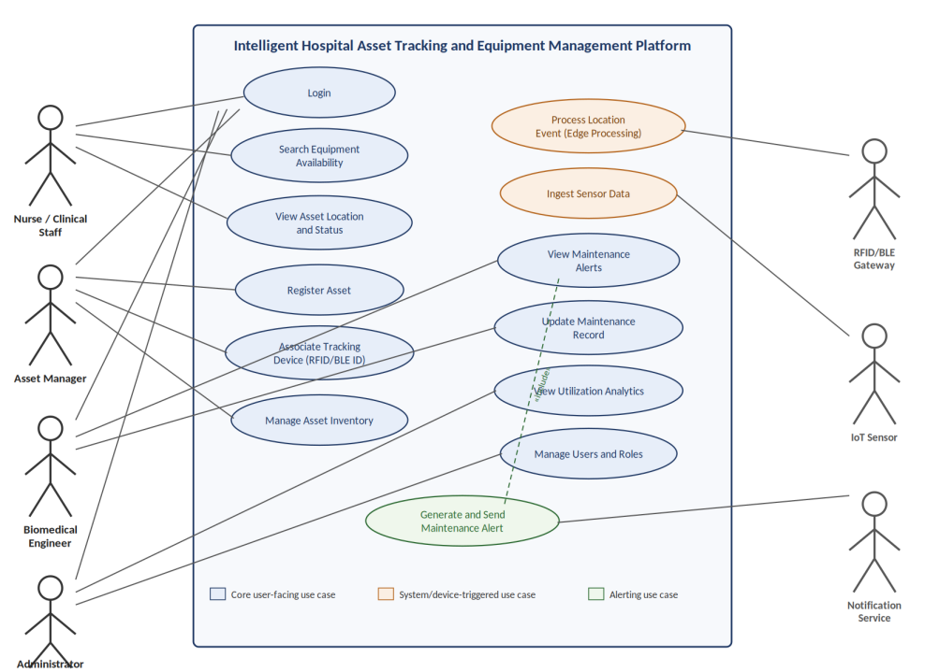
Figure 1: Use Case Diagram — Intelligent Hospital Asset Tracking and Equipment Management Platform

4. Software Requirement Specification (SRS)

4.1 Introduction
This section specifies the requirements for the Intelligent Hospital Asset Tracking and Equipment Management Platform, a software system that tracks the location and condition of shared medical equipment, predicts maintenance needs, and provides role-based dashboards to hospital staff. It is intended for the development team, project supervisors, and hospital stakeholders reviewing the proposed system.

4.2 Problem Description
Hospitals rely on a shared pool of mobile medical equipment that moves constantly between storerooms, corridors, and patient care areas. Current tracking is limited to fixed checkpoint scans, and maintenance is largely reactive, based on failure or fixed calendars rather than actual condition. This results in wasted staff time searching for equipment, inconsistent record-keeping, and a risk of in-use equipment failure. The system to be built must close this gap by combining continuous location tracking, condition monitoring, and predictive maintenance in a single platform.

4.3 Scope of the System
The system covers registration of trackable assets, continuous RFID/BLE location tracking, IoT-based condition monitoring, rule-based and ML-based risk detection, automated alerting and maintenance work-order tracking, and role-based dashboards for nurses, biomedical engineers, and administrators. It is scoped to movable clinical equipment (e.g. ventilators, infusion pumps, monitors) within a hospital or hospital network. It excludes patient clinical data, treatment decision support, and non-trackable disposable items.

4.4 Functional Requirements
ID | Requirement
FR-01 | The system shall allow authorized users to log in using role-based credentials.
FR-02 | The system shall allow an asset manager to register a new asset with a unique asset ID and metadata (type, department).
FR-03 | The system shall allow a unique RFID/BLE tracking-device ID to be associated with a registered asset, and shall reject an attempt to assign an already-assigned tracking ID.
FR-04 | The system shall process raw RFID/BLE gateway signals to determine the current or last-known location of an asset.
FR-05 | The system shall ingest IoT sensor data (battery level, temperature, power/usage state) for each tracked asset.
FR-06 | The system shall allow a user to search for an asset by ID or name and view its location, status, confidence level, and last-updated timestamp.
FR-07 | The system shall evaluate rule-based conditions (e.g. low battery, prolonged idle time, overdue maintenance) against incoming asset data.
FR-08 | The system shall apply a predictive model to estimate equipment failure risk based on historical usage and condition data.
FR-09 | The system shall automatically generate a maintenance alert and work order when a risk threshold is exceeded, and notify the responsible biomedical engineer.
FR-10 | The system shall allow a biomedical engineer to update a maintenance record through inspection, repair, and testing, and to mark the asset as available again.
FR-11 | The system shall maintain a historical log of movement, usage, sensor readings, and maintenance actions for each asset.
FR-12 | The system shall provide role-based dashboards showing information relevant to each actor (availability for nurses, alerts/maintenance for engineers, utilization analytics for administrators).

4.5 Non-Functional Requirements
ID | Category | Requirement
NFR-01 | Performance | Dashboards shall reflect a new location or status event within a few seconds of it being processed.
NFR-02 | Scalability | The system shall support growth from a single department to an entire hospital or multi-hospital network without architectural redesign.
NFR-03 | Reliability / Availability | The system shall tolerate individual reader or network failures without losing critical maintenance alerts, targeting high uptime.
NFR-04 | Security | All data in transit and at rest shall be encrypted, and access shall be restricted by role-based permissions.
NFR-05 | Usability | Dashboards shall be usable by clinical staff with minimal training, under time-pressured conditions.
NFR-06 | Maintainability | Each functional module shall be independently updatable without requiring changes to unrelated modules.
NFR-07 | Interoperability | The system shall expose standard APIs for integration with existing hospital telematics/EHR systems.
NFR-08 | Auditability | Every state change and maintenance action shall be logged and traceable.

4.6 Use Case Descriptions

UC-01: Search Equipment Availability
- Actor: Nurse / Clinical Staff
- Precondition: The user is logged in and the asset has been detected at least once.
- Main Flow: User enters an asset ID or name → system retrieves the current/last-known location, status, confidence level, and last-updated timestamp → system displays the result.
- Postcondition: The user has the information needed to retrieve the equipment.

UC-02: Register Asset and Associate Tracking Device
- Actor: Asset Manager
- Precondition: The user is logged in with asset-manager privileges.
- Main Flow: User enters equipment details and a tracking-device ID → system validates the tracking ID is not already assigned → system creates the asset record and links the tracking device.
- Alternate Flow: If the tracking-device ID is already assigned, the system rejects the registration and displays an error.

UC-03: Generate and Send Maintenance Alert
- Actor: Notification Service (secondary); Biomedical Engineer (recipient)
- Precondition: A rule-based or ML-based risk evaluation has exceeded its threshold for a given asset.
- Main Flow: System creates a maintenance request → Notification Service notifies the responsible biomedical engineer → asset status is updated to 'Maintenance Required'.
- Postcondition: A trackable maintenance work order exists and the engineer has been notified.

4.7 Data Requirements
- Asset data: asset ID, type, department, registration date, current status.
- Tracking data: tracking-device ID, associated asset ID, device type (RFID/BLE).
- Location data: zone/room, timestamp, confidence level.
- Condition data: battery level, temperature, power state, usage duration.
- Maintenance data: work-order ID, reason, assigned engineer, status, resolution, timestamp.
- User data: user ID, role, department, credentials (securely stored).
- Historical data: retained movement, usage, sensor, and maintenance records for analytics.

4.8 External Interface Requirements
- User Interfaces: web-based, role-based dashboards for nurses, biomedical engineers, and administrators.
- Hardware Interfaces: RFID/BLE gateways and IoT sensors communicating over standard wireless protocols.
- Software Interfaces: REST APIs for integration with existing hospital telematics and, where applicable, EHR systems.
- Communication Interfaces: encrypted network communication (e.g. TLS) between devices, gateways, and the backend.

4.9 System Features
- Real-Time Asset Tracking: continuous location updates from RFID/BLE detections.
- Condition Monitoring: live IoT telemetry on battery, temperature, and usage.
- Predictive Maintenance: combined rule-based and ML-based risk scoring.
- Maintenance Workflow: automated alert-to-resolution work-order tracking.
- Role-Based Dashboards: tailored views for nurses, engineers, and administrators.
- Historical Reporting: utilization, downtime, and maintenance analytics.

5. Assumptions and Constraints

5.1 Assumptions
- All trackable equipment can be physically fitted with an RFID or BLE tag without affecting clinical use.
- Hospital departments have adequate Wi-Fi/network coverage to support gateway connectivity.
- Sufficient historical data will be collected before predictive maintenance models are relied upon.
- Hospital staff will receive basic training on the new dashboards before rollout.
- IoT sensors report data at a frequency sufficient for near-real-time monitoring.

5.2 Constraints
- Technical: Reliant on RF signal quality; hospital building materials may cause interference or dead zones.
- Operational: Requires coordinated rollout across clinical, biomedical, and IT departments simultaneously.
- Economic: Upfront hardware cost (tags, gateways, sensors) constrains the pace of full-hospital deployment.
- Legal / Compliance: Data handling must comply with applicable healthcare data protection regulations.
- Time: Sprint-based delivery within an academic/project timeline limits the scope deliverable in early iterations.

6. Requirement Validation — Completeness and Consistency

6.1 Stakeholder Coverage Check
Each identified stakeholder maps to at least one functional requirement and use case: nurses (FR-06, UC-01), asset managers (FR-02, FR-03, UC-02), biomedical engineers (FR-09, FR-10, UC-03), and administrators (FR-12). Procurement and compliance stakeholders are addressed indirectly through the reporting (FR-12) and auditability (NFR-08) requirements rather than dedicated use cases, since they consume outputs rather than interact with the system directly.

6.2 Ambiguity, Redundancy, and Consistency Check
- No conflicting requirements were identified; performance (NFR-01) and reliability (NFR-03) requirements are complementary rather than contradictory.
- FR-07 and FR-08 could initially appear redundant since both concern risk detection; they are kept distinct because the rule engine evaluates deterministic conditions while the ML model evaluates predictive risk, and both feed the same alerting requirement (FR-09).
- The term 'near real-time' in NFR-01 is intentionally qualitative at this stage; a specific numeric target (e.g. under 5 seconds) should be confirmed with stakeholders before implementation to remove ambiguity.

6.3 Identified Gaps and Suggested Improvements
- Add an explicit requirement for offline/degraded-mode behavior when network connectivity to a gateway is lost.
- Add a requirement specifying data retention duration for historical records to support both analytics needs and storage planning.
- Clarify the exact confidence-level calculation referenced in FR-06 and UC-01 as a separate, testable requirement.
- Add a requirement for user consent/notification where equipment usage data may be indirectly associated with a care episode, to support compliance review.

